NAME | CHRISTOPHER LLANDER L. VILLACINO
PROJECT TITLE | ServiFinance: A Multi-Tenant SaaS Service Management System with Embedded Micro-Lending
SUBJECT:  CODE:  TIME: | IT15/L Integrative Programming and Technologies
TOPIC (Type of Business Process) | #33 Service Management System
Products/Services | SaaS platform for Service-Oriented MSMEs
Tools Needed: | Visual Studio 2022/2025– IDE, Visual Studio Code, SSMS, Domain, Hosting
Technology: | ASP.NET Core 10 & Hybrid Web App, Stripe API, ImgBB Api, EF Core
Security Features | Authentication and Authorization (RBAC), Global Query Filtering, Input Validation and Sanitations, Auditing, Logging and Monitoring
Target user/s: | Super Admins, Tenant Admins, Technicians/Dispatchers, Customers
Subs System / Management Transaction/Modules | 1. Service Request Handling  2. Scheduling & Dispatching  3. Service Tracking  4. Customer Feedback  5. Service Reporting
LOGO | 
Project Objectives: | - Centralize Operations: To provide MSMEs with a single cloud-based platform to manage all service-related activities and customer interactions.  - Ensure Data Privacy: To implement a robust multi-tenant architecture that strictly isolates business data between different subscribers.  - Enhance Customer Trust: To improve service transparency through real-time tracking and a formal feedback loop.  - Streamline Payments: To integrate secure digital payment workflows for completed service requests.
Project Description: | ServiFinance targets Philippine MSMEs that operate on a service-request model. This includes computer repair shops, appliance centers, and specialty bakeries. These users require a system that eliminates manual scheduling errors and provides a professional web presence for their clients to track job progress.  The application empowers small businesses by giving them "Enterprise-level" tools at a SaaS price point. It reduces operational overhead, minimizes paper-based tracking, and allows owners to make data-driven decisions based on automated service reports.  The system is built on the .NET 10 ecosystem using Hybrid Web for a reactive web interface. Stripe was chosen for its reliability in handling both one-time service payments and recurring SaaS subscriptions. ImgBB is utilized to keep the database light by offloading image storage to a specialized CDN. These technologies were selected to ensure the system is scalable, secure, and maintainable.
Use Case Diagram  (Role-Based Access) | 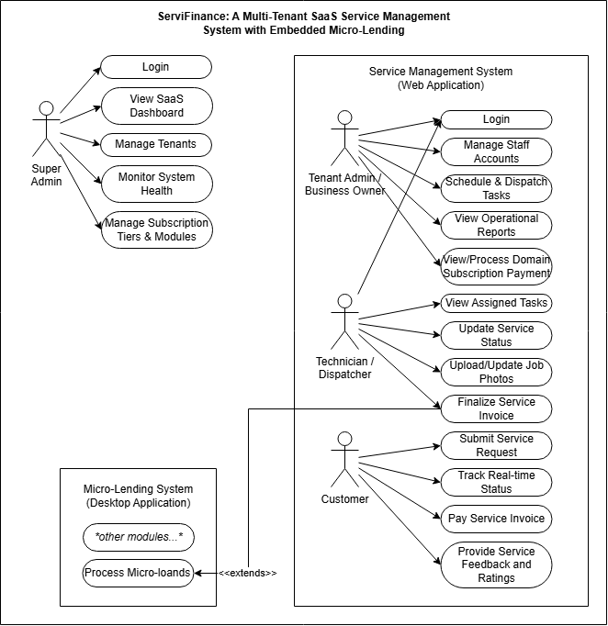  Role-Based Access for Service Management System  Super Admin  - Manage Tenant Subscriptions  - Monitor System Health  - Configure Global Settings  Tenant Admin/Owner  - Manage Staff Accounts  - Schedule & Dispatch Tasks  - View Business Reports  - Oversee All Service Requests  Technician/Dispatcher  - View Assigned Tasks  - Update Job Status  - Upload/Update Service Photos  - Finalize Service Invoice  Customer  - Submit Service Requests  - Track Real-Time Progress  - Pay Service Invoice  - Provide Service Feedback & Ratings
Date Submitted:
Teacher’s Feedback | _________________________________________________________________  _________________________________________________________________  _________________________________________________________________  _________________________________________________________________  _________________________________________________________________  _________________________________________________________________  ________________________________ __________________________  Student’s Signature (after feedbacking) Teacher’s Signature

